

**PROJECT TITLE : AUTOMATIC LAUNDRY MACHINE**

**SECTION : SECT 2**

**LECTURER’S NAME : PROF. DR. SURIANI BINTI SULAIMAN**

|  |  |  |
| --- | --- | --- |
| **NO** | **NAME** | **MATRIC NO.** |
| **1** | **FADHLUDDIN BIN SAHLAN** | **1817445** |
| **2** | **MUHAMMAD ZULHAFIZAL BIN MISRAT** | **1815381** |
| **3** | **MUHAMMAD HAZIM BIN MIR MUNIR** | **1812911** |
| **4** | **MUHAMMAD HAZIQ ADLI BIN ZAMZURI** | **1814981** |

**WE HEREBY DECLARE THIS PROJECT REPORT IS OUR OWN**

**INTRODUCTION**

Automatic Laundry Machine is a program that is designed to ease the users who are doing laundry. This program helps users by providing sufficient information for users to know the status and information of the laundry. One of the features is that the users can easily choose either they want to do washing or drying, where we already put the option for weight, duration and the price consecutively. For washing option, they can choose their desired detergent. They also can determine the temperature of the washer or dryer before they proceed to payment options. We will use the standard payment options which is by using tokens which we converted from the total price of the laundry option. Other than that, our program also can search, display, update and delete user’s data based on their ID number. Users also can know either their laundry had done washing or drying or not. Meanwhile, users can know if the machine at our laundry is vacant or not just by looking at the choosing machine option after they had chosen wash or dry.

**Flowcharts**

1. main()

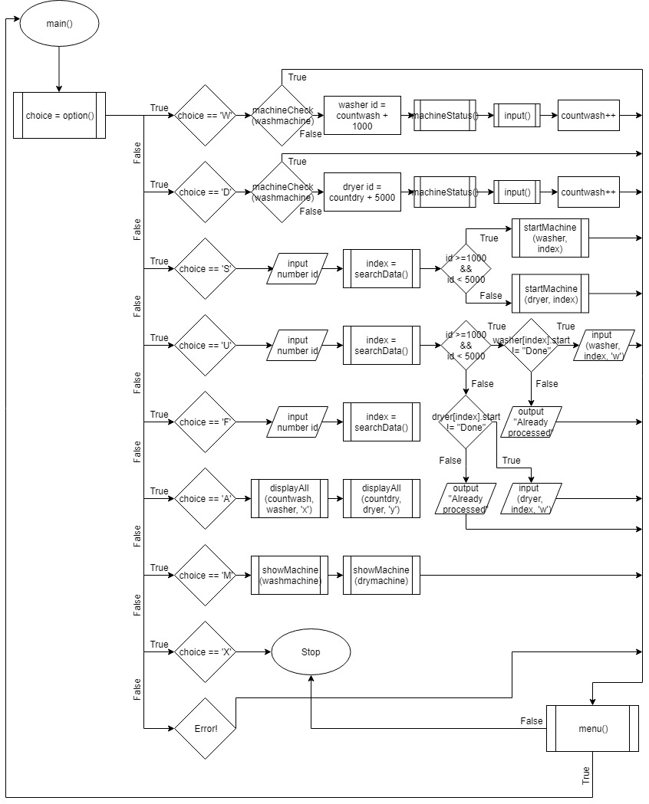

1. input.h

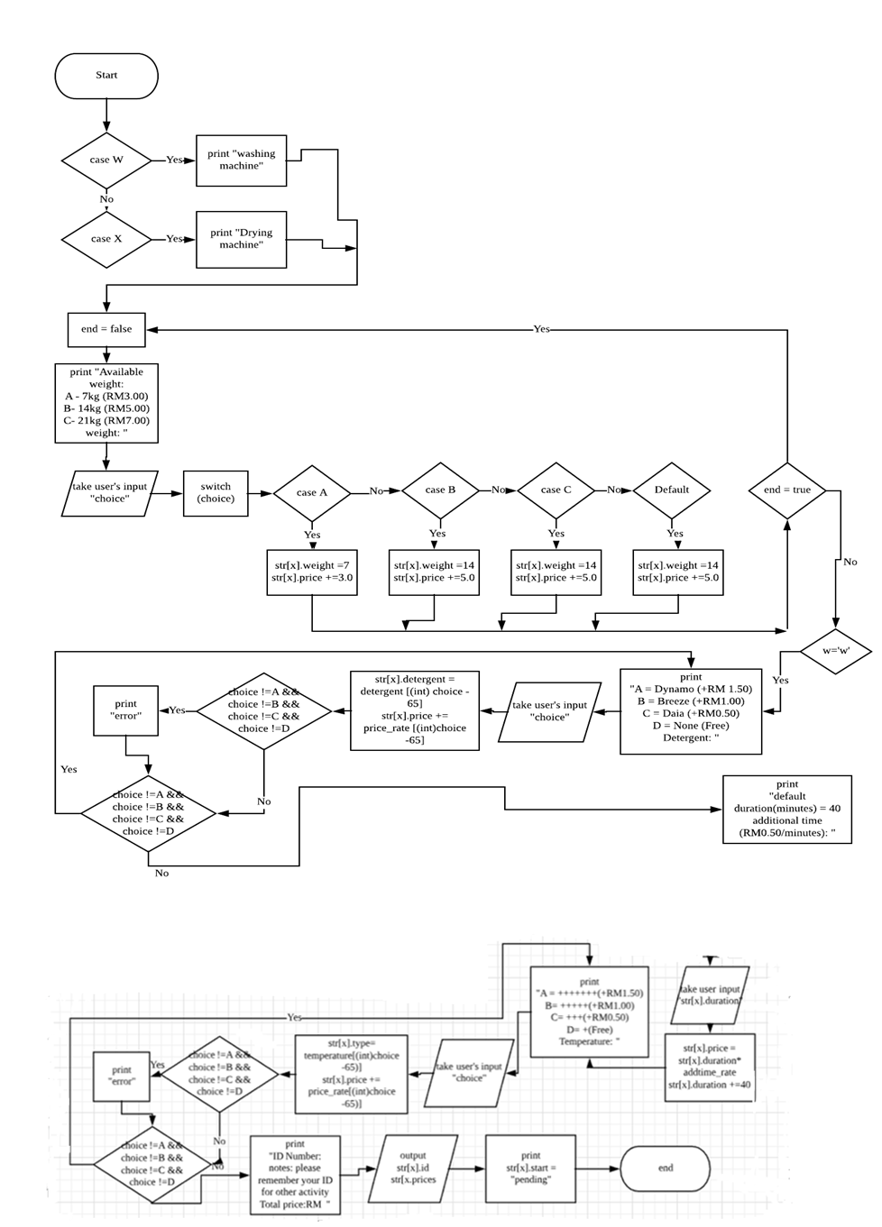

1. option()

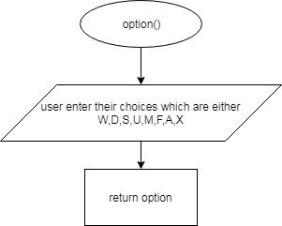

1. machineStatus()

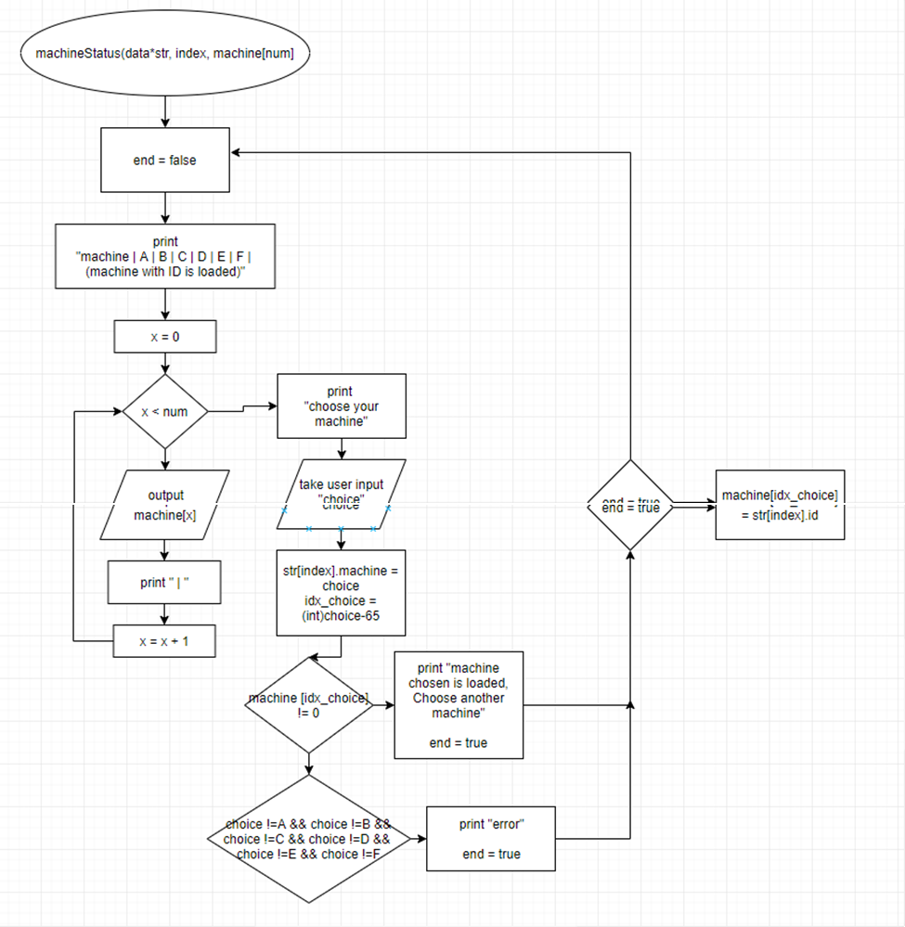

1. searchData()

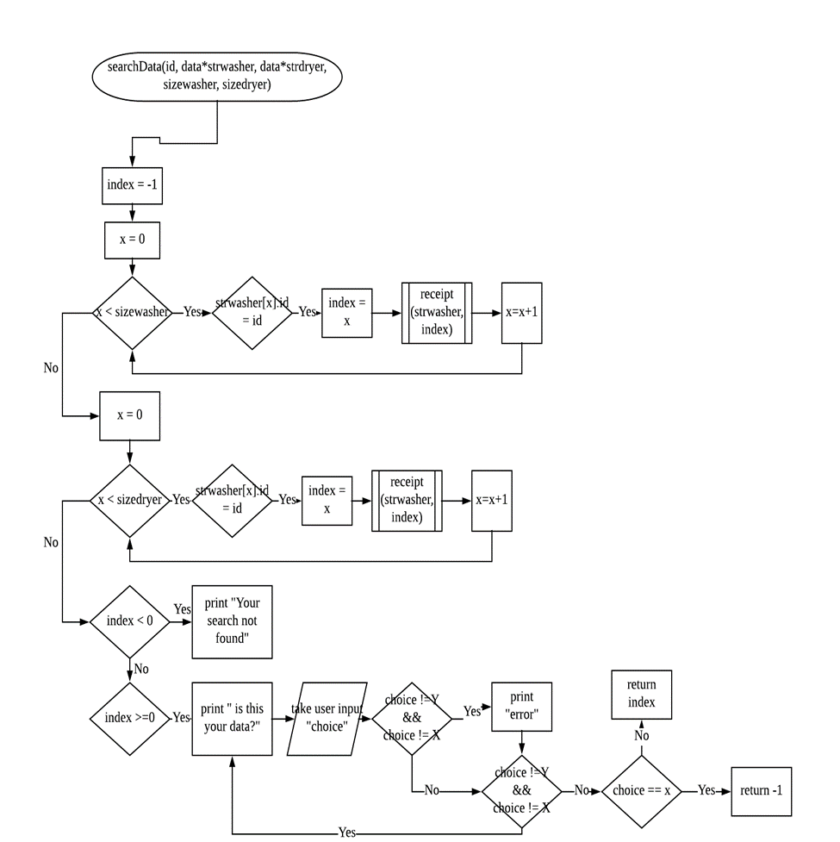

1. startMachine()

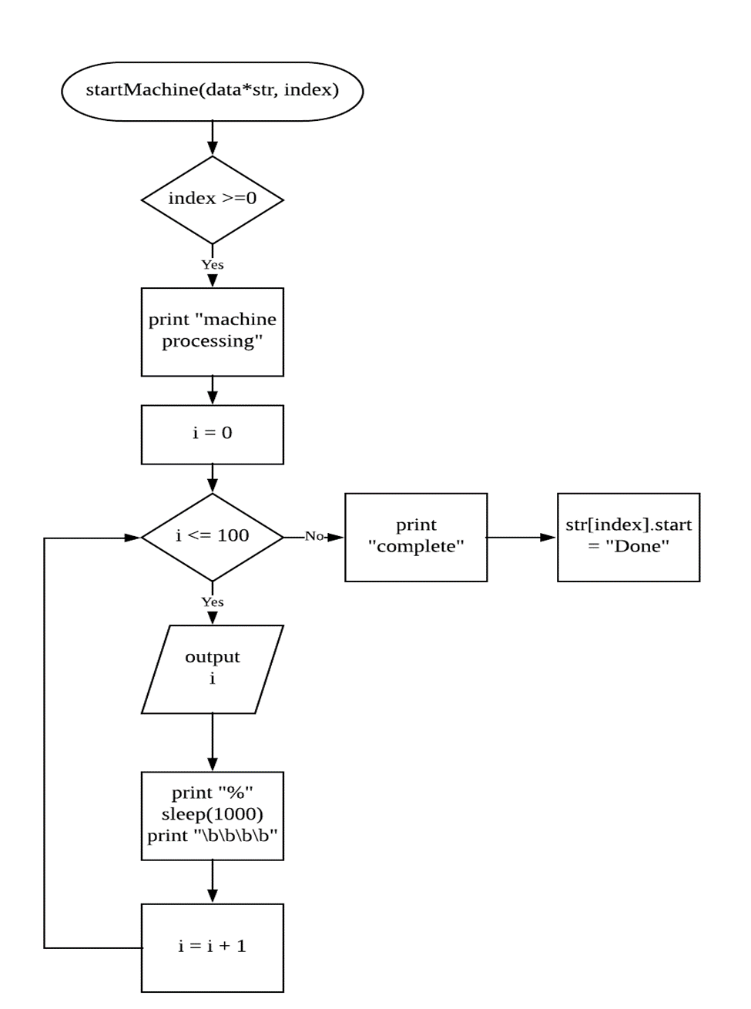

1. showMachine()

print ID number on loaded machine

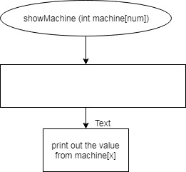

1. displayAll()

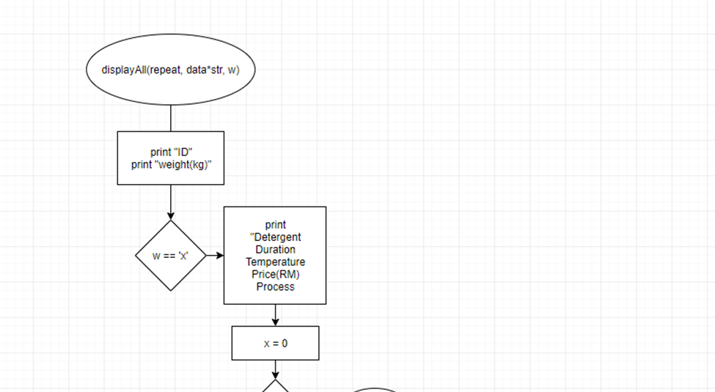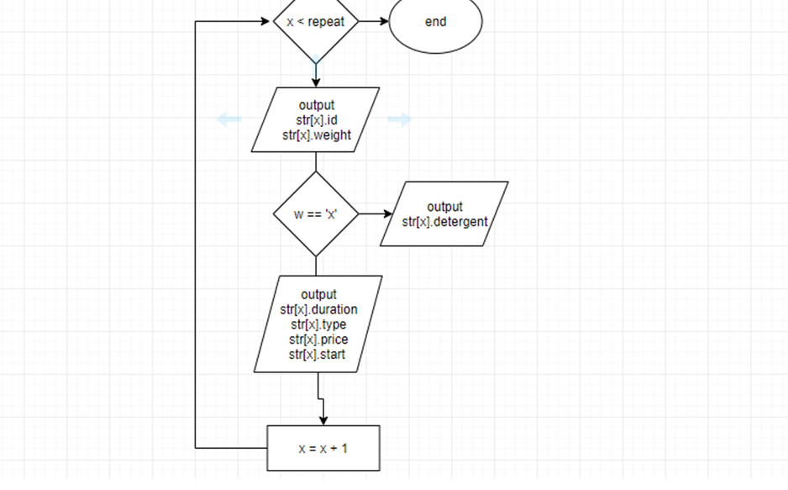

1. receipt()

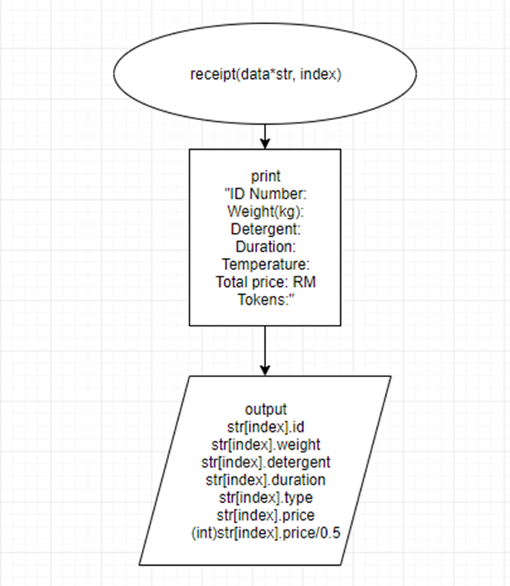

1. menu()

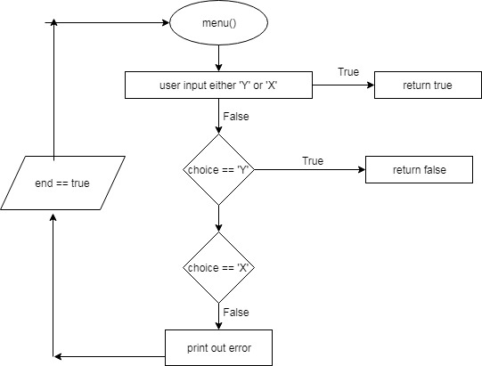

1. machineCheck()

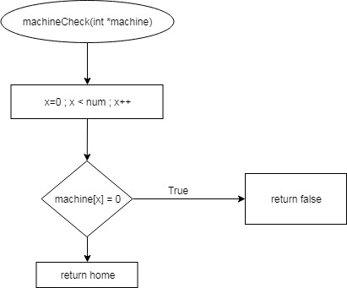

**List of program functions**

* Main ( )
* Dynamic array structure is used in this program to save memory which there are no need of declaration of space in early stage.
* Will only allocate new size for the array structure only if new data are input.
* input ( )
* from header file “input.h”
* Get user laundry's data either washing or drying
* option ( )
* To show the main menu of the laundry
* machineStatus ( )
* To check the status of the laundry machine either it is vacant or not
* searchData ( )
* To search the data that have been insert by the user based on the id number given by system
* For washing process id number given is 1000++ meanwhile for drying process is 5000++
* This function will call the function receipt() to display all related washing and drying data
* startMachine ( )
* To begin the process of washing or drying for pending machine
* showMachine ( )
* To show the status of the machine either it is pending or already completed
* displayAll ( )
* Display all the user’s data about the laundry they have put in
* receipt ( )
* Display all the information for the washing and drying process
* This function will be called at function searchData()
* menu ( )
* Receive the user’s response either to return to main menu or not
* machineCheck ( )
* To check availability of machine before the user input their data

**Sample of screenshots**

